

**CAPSTONE PROJECT 1**

**English For You**

**USER INTERFACE DESIGN DOCUMENT**

Version 1.2

Date: Oct 19, 2018

**MENTOR:** Truong Tien Vu

**MEMBER**: Tran Nguyen Huu Nghia

Do Van Truong

Doan Nu Thuc Oanh

Dinh Tran Anh Truc

**INTERNATIONAL SCHOOL**

**Project Information**

|  |  |  |  |  |  |
| --- | --- | --- | --- | --- | --- |
| **Project acronym** | Eng4you | | | | |
| **Project Tittle** | [E4U] English For You | | | | |
| **Start Date** | Oct 19, 2018 | | **End Date** | | Oct 19, 2018 |
| **Lead Institution** | International School, Duy Tan University | | | | |
| **Project Mentor & contact details** | Mr. Vu Truong Tien  Email: vudalat@yahoo.com  Tel: 0914083188 | | | | |
| **Scrum Master & contact details** | Nghia ,Tran Nguyen Huu  Email: trannguyenhuunghia97@gmail.com  Tel: 0934848229 | | | | |
| **Team members** | **Name** | **Email** | | **Tel** | |
| Truong, Do Van | [Truongdtct1230@gmail.com](mailto:Truongdtct1230@gmail.com) | | 01674275453 | |
| Oanh, Doan Nu Thuc | [Doannuthucoanh0410@gmail.com](mailto:Doannuthucoanh0410@gmail.com) | | 01674552075 | |
| Truc, Dinh Tran Anh | [Anhtruc2091997@gmail.com](mailto:Anhtruc2091997@gmail.com) | | 0947360347 | |

**User Interface Design Document**

|  |  |  |  |
| --- | --- | --- | --- |
| **Document Title** | **User Interface Design** |  |  |
| **Reporting Period** | Oct 19,2018 |  |  |
| **Author(s) &**  **project** | Nghia ,Tran Nguyen Huu  Scrum Master | |  |
| **Team Information** | **Name** | **Role** |  |
| Truong, Do Van | Member |  |
| Oanh, Doan Nu Thuc | Member |  |
| Truc, Dinh Tran Anh | Member |  |
| **Date** | 28 Aug, 2018 | **Filename** | [E4U]User Interface Design Document_Ver1.0.docx |
| **Access** | Project and CMU Program | |  |

**REVISION HISTORY**

|  |  |  |  |
| --- | --- | --- | --- |
| **Version** | **Person** | **Date** | **Description** |
| V1.2 | Team | Sep 12, 2017 | Draft for Document |

**Document Approvals**

The following signatures are required for approval of this document.

|  |  |  |
| --- | --- | --- |
| MSc. Vu, Truong tien  *Mentor & Product Owner* |  | Date: Oct 19, 2018 |
| Nghia, Tran Nguyen Huu  *Scrum Master* |  | Date: Oct 19, 2018 |

**1.** **Introduction** 7

**1.1.** **Purpose** 7

**1.2.** **Scope** 7

**1.3.** **Related Documents** 7

**2.** **List of User Interface for Sprint** 7

**3.** **Describe User Interface for User** 8

**3.1.** **UI-01: Home Page** 8

8

**3.2.** **UI-02: Login** 9

9

**3.3.** **UI-03: Remember Password** 10

**3.4.** **UI-04 : Word Explain Wait page** 10

**3.5.** **UI-05 : Word Explain Play page** 12

1. **Introduction**
   1. **Purpose**

* This document describes the design interface of “E4U English For You Web” System.
  1. **Scope**
* Overview of the stages and modules of the software.
* Create complete interfaces, and describe them clearly.
  1. **Related Documents**

• [E4U]ProductBacklog

• [E4U]ArchitecutreDocument

•.[E4U]DatabaseDesign

1. **List of User Interface for Sprint**

|  |  |  |  |  |
| --- | --- | --- | --- | --- |
| Roles | User Interface ID | UI Name | Description | Notes |
| User | UI-01 | Home Page | This form show to home page of the system (imformations,funcitions,…) |  |
| User | UI-02 | Login | This form is used for user to login the system. |  |
| User | UI-03 | Remember Password | This Interface used for user to remember password each times login again |  |
| User | UI-04 | Word Explain Wait page | This Page is used to display the wait interface when users connect with others player |  |
| User | UI-05 | Word Explain Play page | This page is used to display a game interface for player |  |

1. **Describe User Interface for User**
   1. **UI-01: Home Page**

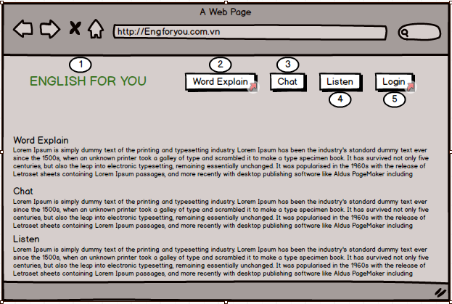

|  |  |  |  |  |  |
| --- | --- | --- | --- | --- | --- |
| From | Condition | Null | Control Type | Target | Notes |
| 1 | Click |  | Text | Click to return home page |  |
| 2 | Click |  | Link | Click to access word explan interface |  |
| 3 | Click |  | Link | Click to access chat interface |  |
| 4 | Click |  | Link | Click to acess Listen game interface |  |
| 5 | Click |  | Link | Click to access login |  |

* 1. **UI-02: Login**

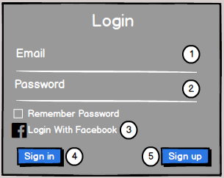

|  |  |  |  |  |  |
| --- | --- | --- | --- | --- | --- |
| From | Condition | Null | Control Type | Target | Notes |
| 1 | Input |  | Textbox | Click to input account |  |
| 2 | Input |  | Textbox | Click to input passwork |  |
| 3 | Click |  | Link | Click to login with facebook |  |
| 4 | Click |  | Button | Click to sign in to the system |  |
| 5 | Click |  | Buttun | Click to register a new account |  |

* 1. **UI-03: Remember Password**



|  |  |  |  |  |  |
| --- | --- | --- | --- | --- | --- |
| From | Condition | Null | Control Type | Target | Notes |
| 1 | Click |  | Check Box | Click to remember password for next login |  |

* 1. **UI-04 : Word Explain Wait page**

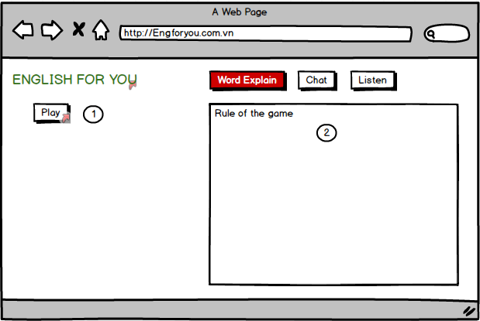

|  |  |  |  |  |  |
| --- | --- | --- | --- | --- | --- |
| From | Condition | Null | Control Type | Target | Notes |
| 1 | Click |  | Button | Click to start connect to others player and moved through timeout |  |
| 2 | View |  | Text | View to Rule of the game |  |

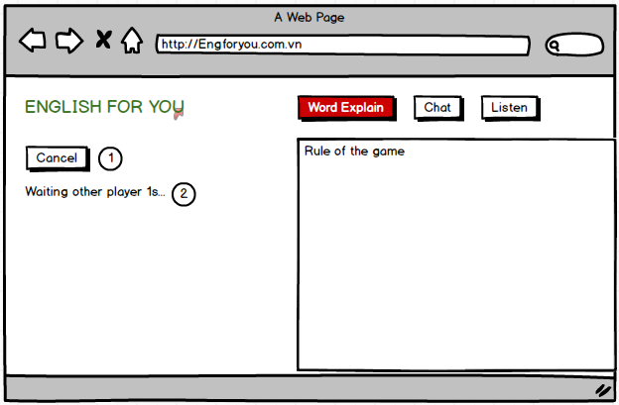

|  |  |  |  |  |  |
| --- | --- | --- | --- | --- | --- |
| From | Condition | Null | Control Type | Target | Notes |
| 1 | Click |  | Button | Click to cancel expected time |  |
| 2 | View |  | Text | View to the waiting time |  |

* 1. **UI-05 : Word Explain Play page**

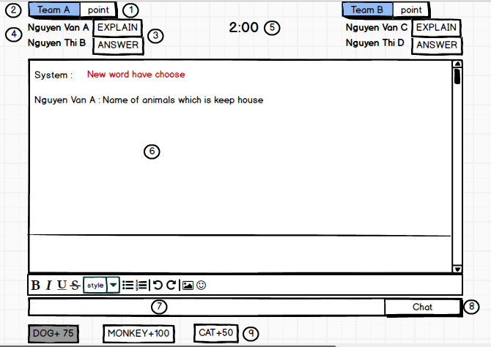

|  |  |  |  |  |  |
| --- | --- | --- | --- | --- | --- |
| From | Condition | Null | Control Type | Target | Notes |
| 1 | view |  | Lable | View to know the point of my team |  |
| 2 | View |  | lable | View to know the name of my team is team A or Team B |  |
| 3 | view |  | lable | View to know my turn is Explain or Answer |  |
| 4 | view |  | lable | View to know name of player |  |
| 5 | view |  | Time | View to know the time of each play turn |  |
| 6 | View |  | Text | View to see the explainations and Answers of others player chat |  |
| 7 | Input |  | Textbox | Click to input the explainations or Answers that you want to chat |  |
| 8 | Click |  | button | Click to push my chat to text chat |  |
| 9 | Click |  | buttun | Click to show question that you want to Reply |  |

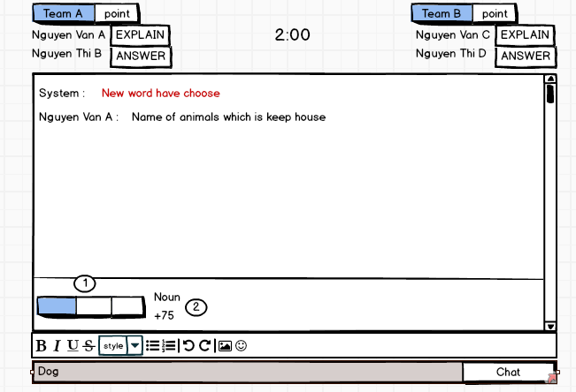

|  |  |  |  |  |  |
| --- | --- | --- | --- | --- | --- |
| From | Condition | Null | Control Type | Target | Notes |
| 1 | View |  | Lable | View to see suggest words number of answer |  |
| 2 | View |  | Text | View to see suggest the type of vocabulary and know point number will be added when Reply true |  |